**Q. Improve any Angular (+NodeJS) application by adding Error Handling.**

**CODE:**

<!DOCTYPE html>

<html>

<head>

<title>Exception handling using AngularJS</title>

</head>

<body ng-app="myApp">

<h1> Error handling in Angular</h1>

<div ng-controller="errHandler">

<p>Enter a number:</p>

<input type="number" ng-model="num" />

<button ng-click="calculate()"> Calculate</button>

<p>Result: {{result}}</p>

<p>Any Exception: {{errorMessage}}</p>

</div>

<script src="https://ajax.googleapis.com/ajax/libs/angularjs/1.7.9/angular.min.js"></script>

<script>

angular.module('myApp', []).controller('errHandler', function ($scope, $exceptionHandler) {

$scope.calculate = function () {

try {

if ($scope.num < 0) {

$scope.result = "Not Possible";

throw new Error("Number must be positive !!")

}

$scope.result = Math.sqrt($scope.num);

$scope.errorMessage = "No Exception Occurred";

}

catch (e) {

$scope.errorMessage = e.message;

$exceptionHandler(e);

}

}

})

</script>

</body>

</html>

**OUTPUT:**

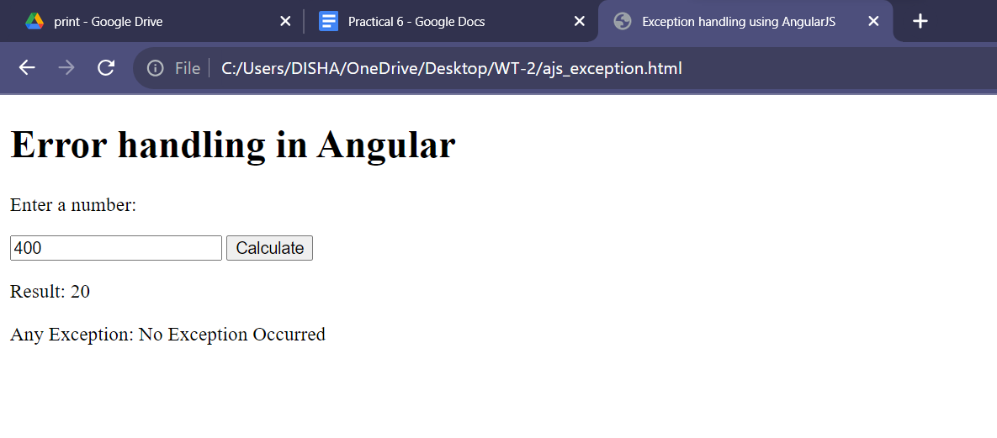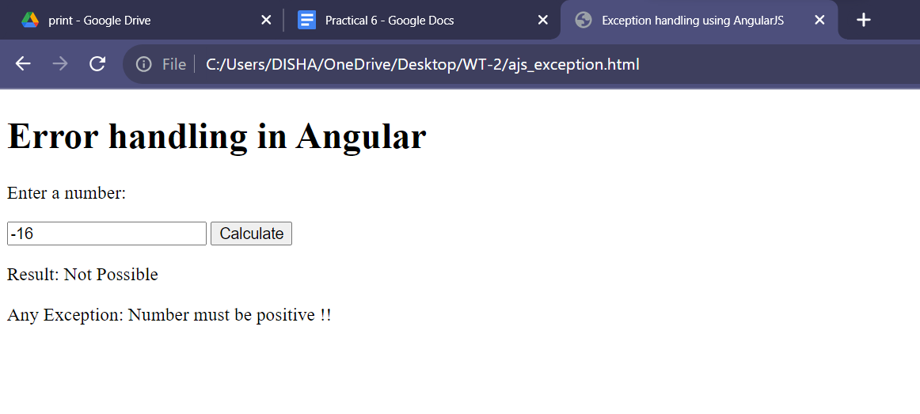

**Q. Form Validation.**

**CODE:**

<!DOCTYPE html>

<html ng-app="myApp">

<head>

<title>AngularJS Validation and Error Handling</title>

<link rel="stylesheet" href="https://maxcdn.bootstrapcdn.com/bootstrap/3.3.7/css/bootstrap.min.css">

<script src="https://ajax.googleapis.com/ajax/libs/angularjs/1.6.9/angular.min.js"></script>

<script src="https://cdnjs.cloudflare.com/ajax/libs/angular-messages/1.6.9/angular-messages.min.js"></script>

<style>

body {

margin: 20px;

}

.has-error {

border-color: red;

}

.ng-invalid.ng-touched,

.ng-submitted .ng-invalid {

background-color: #ffe6e6;

}

</style>

</head>

<body ng-controller="FormController">

<form name="myForm">

<div class="form-group"

ng-class="{'has-error': myForm.username.$invalid && (myForm.username.$touched || myForm.$submitted)}">

<label for="username">Username:</label>

<input id="username" name="username" type="text" ng-model="username" ng-pattern="/^[a-zA-Z0-9]+$/"

required>

<ng-messages for="myForm.username.$error" ng-show="myForm.username.$touched || myForm.$submitted">

<ng-message when="required">Username is required.</ng-message>

<ng-message when="pattern">Please use alphanumeric characters.</ng-message>

</ng-messages>

<ng-messages for="backendErrors.username" ng-show="myForm.username.$touched || myForm.$submitted">

<ng-message ng-repeat="message in backendErrors.username">{{ message }}</ng-message>

</ng-messages>

</div>

<div class="form-group"

ng-class="{'has-error': myForm.password.$invalid && (myForm.password.$touched || myForm.$submitted)}">

<label for="password">Password:</label>

<input id="password" name="password" type="password" ng-model="password" ng-minlength="4" required>

<ng-messages for="myForm.password.$error" ng-show="myForm.password.$touched || myForm.$submitted">

<ng-message when="required">Password is required.</ng-message>

<ng-message when="minlength">Password must be at least 4 characters.</ng-message>

</ng-messages>

</div>

<div class="form-group">

<button class="btn btn-primary" ng-click="submitForm()">Submit</button>

</div>

</form>

<script>

var app = angular.module('myApp', ['ngMessages']);

app.controller('FormController', function ($scope) {

$scope.backendErrors = {};

$scope.submitForm = function () {

try {

if ($scope.myForm.$invalid) {

$scope.myForm.$setSubmitted();

return;

}

if ($scope.username === 'invalid') {

throw new Error('Username is invalid');

}

alert('Form submitted successfully');

} catch (error) {

console.error('An error occurred:', error);

$scope.backendErrors.username = ['An error occurred on the server'];

}

};

});

</script>

</body>

</html>

**OUTPUT:**

